WP400296 08/25

Sample member communication content: Information on how employees can bulk transfer their pension pot to Aegon

To help you communicate details about your Aegon workplace pension scheme to employees, we’ve produced this sample copy for you to use.

We’ve taken all reasonable care to make sure the information is accurate at the time of issue, but we don’t accept liability for any consequences resulting from its use.

There are certain rules you must follow when promoting your company pension scheme to your employees. You can find out more about these on The Pension Regulator’s website.

Dear Colleague

Offer to bulk transfer (ceding provider) pension pot to Aegon
Now you’re all set with your new Aegon workplace pension, it’s a good time to think about what you want to do with the pension pot you’ve already built up in the previous (ceding provider) scheme.

Aegon will send you an email on (insert date) (it’ll come from email@emails.aegon.co.uk so check your spam or junk folder) which is your offer to transfer your previous (insert company name) pension pot.

Simple steps to transfer

After reading all the information from Aegon, you’ll be able to create an online account using the Create account link in their email and then, if you’re happy to transfer, follow the online instructions.
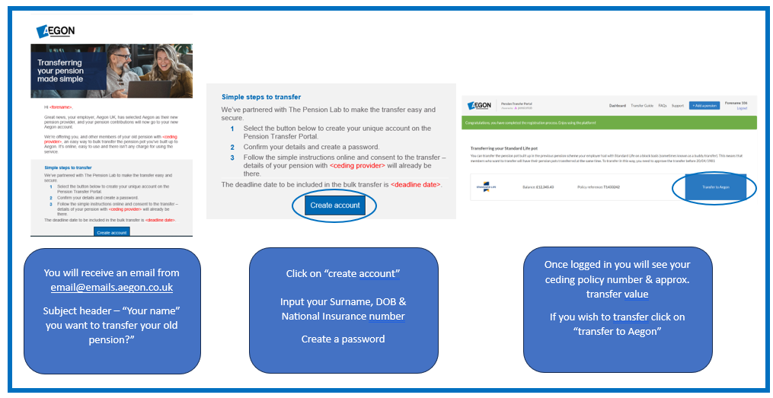

You have until (insert date) to tell Aegon you wish to transfer as part of the bulk transfer offer. After this time, you can still choose to transfer, however this will be an individual transfer and timescales for this will differ.

Next steps

(ceding provider) have agreed a disinvestment date of w/c (insert date) for the bulk transfer. This means your transfer value won’t be transferred to Aegon until then.

If you choose to transfer, once Aegon receive your transfer value, they’ll apply them to your new Aegon account and confirm, by email, that your transfer is complete. You’ll be able to log in to your account to check all the details.

